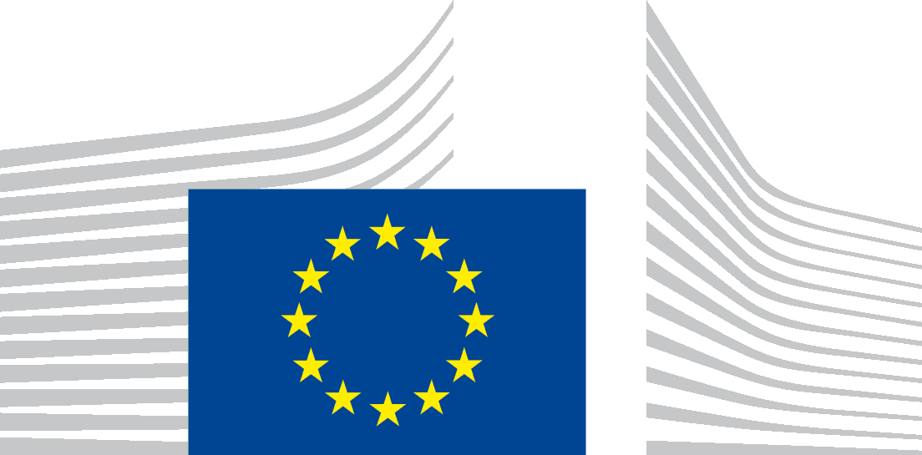 | EUROPEAN COMMISSION

PROTECTION OF YOUR PERSONAL DATA

Processing operation: Market consultation activities in the context of procurement of information and communications technology services and/or supplies organized by the Directorate-General for Digital Services of the European Commission
Data Controller: The European Commission, represented by the Directorate-General for Digital Services, Unit R3 – Procurement and Legal Compliance (the ‘data controller’)
Record reference: DPR-EC-01011

Table of Contents
- Introduction
- Why and how do we process your personal data?
- On what legal ground(s) do we process your personal data?
- Which personal data do we collect and further process?
- How long do we keep your personal data?
- How do we protect and safeguard your personal data?
- Who has access to your personal data and to whom is it disclosed?
- What are your rights and how can you exercise them?
- Contact information
- Where to find more detailed information?

- Introduction
The European Commission (hereafter ‘the Commission’) is committed to protect your personal data and to respect your privacy. The Commission collects and further processes personal data pursuant to Regulation (EU) 2018/1725 of the European Parliament and of the Council of 23 October 2018 on the protection of natural persons with regard to the processing of personal data by the Union institutions, bodies, offices and agencies and on the free movement of such data (repealing Regulation (EC) No 45/2001).
This privacy statement explains the reason for the processing of your personal data, the way we collect, handle and ensure protection of all personal data provided, how that information is used and what rights you have in relation to your personal data. It also specifies the contact details of the responsible Data Controller with whom you may exercise your rights, the Data Protection Officer and the European Data Protection Supervisor.
The information in relation to the processing of personal data linked to the market consultation activities organised by the data controller is presented below.
- Why and how do we process your personal data?
The data controller collects and uses your personal information within the framework of market consultation activities to obtain your views on a specific initiative related to the procurement of information and communications technology (ICT) services and/or supplies. Your views and input are indispensable to design, prepare and finalise such procurement procedures. However, as the subject-matter of these consultations will never require you to provide information about your personal life, we ask you to avoid any reference in your submission or contribution that would reveal aspects of your personal life.
The purpose of the processing is limited to the management of public consultations in accordance with Article 166 (1) of the Financial Regulation (EU, Euratom) 2018/1046. More specifically, your personal data are processed for the following purposes:
- to allow you to access the relevant digital and physical spaces where the consultation takes place (registration purpose);
- to allow you to submit your views and contributions (submission purpose)
- to ensure that you can be contacted for the relevant consultation (communication purpose)
- to ensure that the views and contributions of the company you represent is duly considered when the contributions are summarised in a dedicated internal report (identification purpose)
In some cases, the data controller already has your contact details as you have previously participated in similar market consultation activities. When the data controller does not already have your contact information, it will collect that information in the context of the relevant market consultation.
Depending on the circumstances of the market consultation, the data controller may decide to:
- carry out the market consultation activity using EU Survey;
- carry out the market consultation activity using a Europa website;
- carry out market consultation activity using a third-party videoconference IT tool such as Microsoft Teams, including by making audio/video recordings;
- carry out market consultation activity via in-person meetings.
Accordingly,
- In case of use of the Commission's online questionnaire tool EU Survey that requires you to login via your ‘EU Login’ or ‘social media account’. ‘EU Login’ requires certain personal data such as the name, surname and e-mail address of the registrant. For further information, please refer to the privacy statements of ‘EU Login’ and ‘EU Survey’ as well as the processing operations ‘Identity & Access Management Service (IAMS)' (reference number in the public DPO register: DPR-EC-03187) and ‘EUSurvey’ (reference number: DPR-EC-01488). Should you choose to log in through your social media account, please refer to the pertinent social media platform’s privacy statement.
- In some cases, the market consultation activity uses wiki platforms. In such cases, your personal data will be processed in the context of Europa websites managed by the European Commission. For further information, please refer to the privacy statement of Europa website.
- In some cases, market consultation meetings can be carried out using a third-party videoconference IT tool such as Microsoft Teams. During these meetings, you may be recorded if that is necessary to collect your views and to keep internal reference. The cookies and privacy policy of this IT tool is available here: Microsoft Teams Commission Record DPR-EC-4966).
- In case of in-person meetings, your personal data will be processed to ensure access to Commission premises (see Record of Processing DPR-EC-00655 (Commission Physical Access Control System (PACS))
Please note that your contribution to the targeted consultations can be stored in the Commission’s document management system (for further information on the Commission’s document management system please refer to the processing operation ‘Management and (short- and medium-term) preservation of Commission documents`, reference number: DPR-EC-00536).
The personal data processed may be reused for the purpose of procedures before the EU Courts, national courts, the European Ombudsman or the European Court of Auditor.
Your personal data will not be used for automated decision-making, including profiling.

- On what legal ground(s) do we process your personal data
We process your personal data, because:
(a) processing is necessary for the performance of a task carried out in the public interest;
The Union law which is the basis for the processing based on Article 5(1)(a) of Regulation (EU) 2018/1725 is the Treaty of the European Union, and more specifically its Articles 1 and 11, Article 298 of the Treaty on the Functioning of the European Union, read in conjunction with Recital 22 of Regulation (EU) 2018/1725), as well as the Protocol 2 on the application of the principles of subsidiarity and proportionality and Article 166(1) and Point 15 of Annex 1 of the Financial Regulation.
- Which personal data do we collect and further process?
In order to carry out this processing operation the following categories of personal data may be processed:

- name and surname,
- profession,
- professional contact information such as e-mail address and phone number of the respondent,
- any other personal data included in the response or contribution to the targeted consultation activity
- audio/video recording.

Furthermore, you may spontaneously provide other, non-requested personal data in the context of your reply to the targeted consultation.

- How long do we keep your personal data?
The Data Controller only keeps your personal data for the time necessary to fulfil the purpose of collection or further processing, namely for a maximum of five years after the closure of the file to which the present market consultation belongs. A file is closed at the latest once there has been a final outcome in relation to the initiative to which the targeted consultation contributed (e.g. signature of the relevant contract).
This administrative retention period of five years is based on the retention policy of European Commission documents and files (and the personal data contained in them), governed by the common Commission-level retention list for European Commission files SEC(2022)400 . It is a regulatory document in the form of a retention schedule that establishes the retention periods for different types of European Commission files. That list has been notified to the European Data Protection Supervisor.
The administrative retention period is the period during which the Commission departments are required to keep a file depending on its usefulness for administrative purposes and the relevant statutory and legal obligations. This period begins to run from the time when the file is closed.
In accordance with the common Commission-level retention list, after the ‘administrative retention period’, files including (the outcome of) targeted consultations (and the personal data contained in them) can be transferred to the Historical Archives of the European Commission for historical purposes (for the processing operations concerning the Historical Archives, please see record of processing 'Management and long-term preservation of the European Commission's Archives’, registered under reference number DPR-EC-00837).
- How do we protect and safeguard your personal data?
All personal data in electronic format (e-mails, documents, databases, uploaded batches of data, etc.) are stored on the servers of the Commission or of its contractors. All processing operations are carried out pursuant to Commission Decision (EU, Euratom) 2017/46 of 10 January 2017 on the security of communication and information systems in the Commission.
In order to protect your personal data, the Commission has put in place a number of technical and organisational measures. Technical measures include appropriate actions to address online security, risk of data loss, alteration of data or unauthorised access, taking into consideration the risk presented by the processing and the nature of the personal data being processed. Organisational measures include restricting access to the personal data solely to authorised persons with a legitimate need to know for the purposes of this processing operation.
The Commission’s processors (contractors) are bound by contractual commitments for any processing operations of your personal data on behalf of the Commission. The processors have to put in place appropriate technical and organisational measures to ensure the level of security, required by the Commission.
- Who has access to your personal data and to whom is it disclosed?
Access to your personal data is provided to the Commission staff responsible for carrying out this processing operation and to authorised staff according to the ‘need to know’ principle, in particular to follow-up on the targeted consultation. Such staff abide by statutory, and when required, additional confidentiality agreements.
Please note that pursuant to Article 3(13) of Regulation (EU) 2018/1725 public authorities (e.g. Court of Auditors, EU Court of Justice) which may receive personal data in the framework of a particular inquiry in accordance with Union or Member State law shall not be regarded as recipients; the processing of those data by those public authorities shall be in compliance with the applicable data protection rules according to the purposes of the processing.
Access to your personal data is provided to authorised staff according to the ‘need to know’ principle.
The information we collect will not be given to any third party, except to the extent and for the purpose we may be required to do so by law.
- What are your rights and how can you exercise them?
You have specific rights as a ‘data subject’ under Chapter III (Articles 14-25) of Regulation (EU) 2018/1725, in particular the right to access your personal data and to rectify them in case your personal data are inaccurate or incomplete. Under certain conditions, you have the right to erase your personal data, to restrict the processing of your personal data, to object to the processing and the right to data portability.

You have the right to object to the processing of your personal data, which is lawfully carried out pursuant to Article 5(1)(a), on grounds relating to your particular situation.

Insofar as you have consented to the certain processing of your personal data to the Data Controller for the present processing operation, you can withdraw your consent at any time by notifying the Data Controller. The withdrawal will not affect the lawfulness of the processing carried out before you have withdrawn the consent.

You can exercise your rights by contacting the Data Controller, or in case of conflict the Data Protection Officer. If necessary, you can also address the European Data Protection Supervisor. Their contact information is given under Heading 9 below.
Where you wish to exercise your rights in the context of one or several specific processing operations, please provide their description (i.e. their Record reference(s) as specified under Heading 10 below) in your request.
In accordance with Article 14(3) of Regulation (EU) 2018/1725, your request as a data subject will be handled within one month of receipt of the request. That period may be extended by two further months where necessary, taking into account the complexity and number of the requests. In such case you will be informed of the extension of the time limit, together with the reasons for the delay.
- Contact information
- The Data Controller
If you would like to exercise your rights under Regulation (EU) 2018/1725, or if you have comments, questions or concerns, or if you would like to submit a complaint regarding the collection and use of your personal data, please contact the Data Controller at DIGIT-CONTRACTS-INFO-CENTRE@ec.europa.eu.
- The Data Protection Officer (DPO) of the Commission
You may contact the Data Protection Officer (DATA-PROTECTION-OFFICER@ec.europa.eu)) with regard to issues related to the processing of your personal data under Regulation (EU) 2018/1725.

- The European Data Protection Supervisor (EDPS)

You have the right to recourse (i.e. you can lodge a complaint) to the European Data Protection Supervisor (edps@edps.europa.eu) if you consider that your rights under Regulation (EU) 2018/1725 have been infringed as a result of the processing of your personal data by the Data Controller.
- Where to find more detailed information?
The Commission Data Protection Officer (DPO) publishes the register of all processing operations on personal data by the Commission, which have been documented and notified to him. You may access the register via the following link: http://ec.europa.eu/dpo-register.
This specific processing operation has been included in the DPO’s public register with the following Record reference: DPR-EC-01011.

