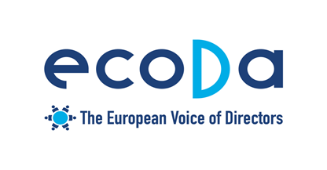

EC Conference on Sustainable Corporate Governance – 24 January 2019
Proposal for introduction - Michel DE FABIANI, Chairman Policy Committee ecoDa

- Directors act in the interest of corporations as a full entity acting in an economic and social environment.
- All legitimate stakeholders’ interests are taken into account as long as they are relevant for the company’s purpose (to ensure long term viability of the company).
- Legislations and codes include stakeholders considerations but corporations cannot resolve political and societal issues!

- DIRECTORS ACT IN THE INTEREST OF THE COMPANY AS DEFINED BY THE SHAREHOLDERS
- Shareholders: no shareholder / no company!
- It is up to the shareholders to define the company purpose at the constitution moment or in a later phase –must not necessarily mean that the purpose of the company must be to make money, can very well be to promote socially good causes (can be done in a broader way than just “profit maximization”);
- The legislator should leave it up to each company to define the level of details when defining the company’s raison d’être;
- Giving precedence to the shareholders’ interests in defining the company’s purpose does not mean that the interests of other stakeholders should not be taken into account by the directors when fulfilling their duties towards the company.
- The board is obliged to take into account the interest of the legitimate stakeholders that are deemed consistent with the company’s purpose;
  - Internal stakeholder : Employees are Nr1 including Employee Representatives
  - Direct external stakeholders:
    - Suppliers
    - Customers
    - Professional Unions
    - Societal stakeholders:
    - HSSE policies and actions
    - Legislators and Regulators
- However, turning boards into courts of arbitration is not an option. Boards should not become consultative bodies where all opinions can be expressed and can hold-up decisions (We should avoid situation encountered in boards of state-owned enterprises where large boards of stakeholder representatives become more of a parliament with fractions that vote, rather than collegial bodies that reach consensus);
- Boards need clear accountability rules: “being liable to everybody means being liable to nobody”

- BEST PRACTICES OF BOARDS OF DIRECTORS

- Board Agendas including and starting with
- Society review : political situation/ countries/regions/ cities
- Employees review
- Suppliers/customers review
- Financial review / past / forecast
- Shareholders review
- Strategy implementation

- Board Committees prepare board discussions and present on each of their topic
- Strategy/ Governance/CSR/Audit / Nominations/ Remuneration

- Strategy seminar for all Board members on a yearly basis with
- Update at each Board meeting.
- Full day meetings with presentations by Top Executives
CONCLUSION
- Long term sustainability of the company includes all aspects of the company impact on the social, economic and environmental stakeholders.
- Long term sustainability is the main goal subject to financial performance and viability!

