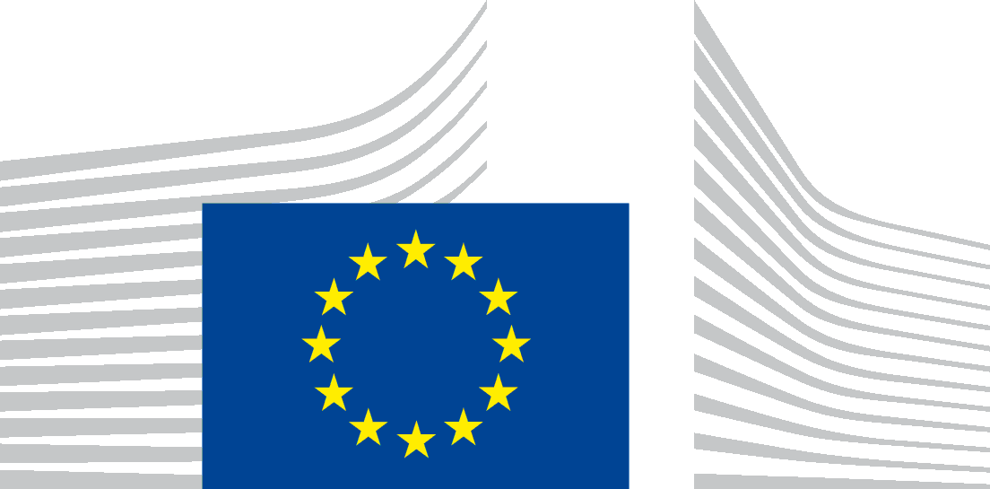 | EUROPEAN COMMISSION  DIRECTORATE-GENERAL FOR EDUCATION AND CULTURE  Library and e-Resources Centre

CALL FOR TENDERS
Open procedure N° EAC/22/2016

Security Framework

TABLE OF CONTENTS
1.Introduction 4
2.Security Objectives 5
3.Effectiveness Assurance Levels 7
4.Demonstration of Security Objectives' Effectiveness 8

Introduction
This document defines Security Objectives relevant for the provision of cloud-based services requested in this call for tenders. These security objectives are based on the ENISA Cloud Certification Schemes Metaframework (v1.0, available from https://resilience.enisa.europa.eu/cloud-computing-certification/cloud-computing-certification).
Compliance with these security objectives can be established through the mapping of cloud providers' security controls and practices into existing industry standards such as, for example, ISO 27000-based or equivalent standards.
Cloud providers are requested to document their control effectiveness assurance using the Effectiveness Assurance Levels (EAL's) defined in section 3 of this Annex.

Security Objectives
The list of Security Objectives relevant for the call for tenders is listed below:
# | Security Objectives | Security Objectives Descriptions
SO-01 | Information security policy | Cloud provider establishes and maintains an information security policy.
SO-02 | Risk management | Cloud provider establishes and maintains an appropriate governance and risk management framework, to identify and address risks for the security of the cloud services.
SO-03 | Security roles | Cloud provider assigns appropriate security roles and security responsibilities.
SO-04 | Security in Supplier relationships | Cloud provider establishes and maintains a policy with security requirements for contracts with suppliers to ensure that dependencies on suppliers do not negatively affect security of the cloud services.
SO-05 | Background checks | Cloud provider performs appropriate background checks on personnel (employees, contractors and third party users) if required for their duties and responsibilities.
SO-06 | Security knowledge and training | Cloud provider verifies and ensures that personnel have sufficient security knowledge and that they are provided with regular security training.
SO-07 | Personnel changes | Cloud provider establishes and maintains an appropriate process for managing changes in personnel or changes in their roles and responsibilities.
SO-08 | Physical and environmental security | Cloud provider establishes and maintains policies and measures for physical and environmental security of cloud datacentres.
SO-09 | Security of supporting utilities | Cloud provider establishes and maintains appropriate security of supporting utilities (electricity, fuel, etc.).
SO-10 | Access control to network and information systems | Cloud provider establishes and maintains appropriate policies and measures for access to cloud resources.
SO-11 | Integrity of network and information systems | Cloud provider establishes and maintains the integrity of its own network, platforms and services and protect from viruses, code injections and other malware that can alter the functionality of the systems.
SO-12 | Operating procedures | Cloud provider establishes and maintains procedures for the operation of key network and information systems by personnel.
SO-13 | Change management | Cloud provider establishes and maintains change management procedures for key network and information systems.
SO-14 | Asset management | Cloud provider establishes and maintains asset management procedures and configuration controls for key network and information systems.
SO-15 | Security incident detection and response | Cloud provider establishes and maintains procedures for detecting and responding to incidents appropriately.
SO-16 | Security incident reporting | Cloud provider establishes and maintains appropriate procedures for reporting and communicating about security incidents.
SO-17 | Business continuity | Cloud provider establishes and maintains contingency plans and a continuity strategy for ensuring continuity of cloud services.
SO-18 | Disaster recovery capabilities | Cloud provider establishes and maintains an appropriate disaster recovery capability for restoring cloud services provided in case of natural and/or major disasters.
SO-19 | Monitoring and logging policies | Cloud provider establishes and maintains systems for monitoring and logging of cloud services.
SO-20 | System tests | Cloud provider establishes and maintains appropriate procedures for testing key network and information systems underpinning the cloud services.
SO-21 | Security assessments | Cloud provider establishes and maintains appropriate procedures for performing security assessments of critical assets.
SO-22 | Checking compliance | Cloud provider establishes and maintains a policy for checking compliance to policies and legal requirements.
SO-23 | Cloud data security | Cloud provider establishes and maintains appropriate mechanisms for the protection of the customer data in the cloud service.
SO-24 | Cloud interface security | Cloud provider establishes and maintains an appropriate policy for keeping cloud services interfaces secure.
SO-25 | Cloud software security | Cloud provider establishes and maintains a policy for keeping software secure.
SO-26 | Cloud interoperability and portability | Cloud provider uses standards which allow customers to interface with other cloud services and/or if needed migrate to other providers offering similar services.
SO-27 | Cloud monitoring and log access | Cloud provider provides customers with access to relevant transaction and performance logs so customers can investigate issues or incidents when needed.

Effectiveness Assurance Levels
The detailed list of Effectiveness Assurance Levels relevant for the call for tenders is provided below:
Effectiveness Assurance Levels (EAL's) | Descriptions
EAL-0 | There is no assurance that the security objective is met. Such an 'assurance level' essentially makes the affected security objective and security controls non-mandatory for evaluation. Cloud providers are nevertheless expected to exercise due care and follow best practices in their compliance with the security objective and implementation of the relevant security controls.
EAL-1 | The assurance that the security objective is met is provided by legally binding service description and contractual documents (including providers' responses to the call for tenders).
EAL-2 | The assurance that the security objective is met is provided by a self- assessment performed by cloud providers, which must contain the list of implemented security controls. This is equivalent to 'CSA STAR 1: Self- Assessment' in the STAR (Security, Trust and Assurance Registry) Program of the CSA (Cloud Security Alliance).
EAL-3 | The assurance that the security objective is met is provided by audit reports delivered by cloud providers' internal audit departments.
EAL-4 | The assurance that the security objective is met is provided by audit reports delivered by EU Member States or independent auditors (equivalent to 'CSA STAR 2: 3rd-party assessment-based certification').
EAL-5 | The assurance that the security objective is met is provided by continuous monitoring-based certification, equivalent to 'CSA STAR 3'.

Demonstration of Security Objectives' Effectiveness
Answers to IT security objectives of section 2 must include material that is compatible with descriptions of Effectiveness Assurance Levels defined in section 3.
As an illustration of EAL's principles used in this call for tenders, below is an example of a partial matrix showing the assurance levels on a number of ISO 27002 security controls of a cloud provider, allowing assessing its security posture.
The matrix refers to the methodology of the certification system of the Cloud Security Alliance (CSA). "The CSA Security, Trust and Assurance Registry (STAR) program is a comprehensive set of offerings for cloud provider trust and assurance. The CSA STAR Program is a publicly accessible registry designed to recognize the varying assurance requirements and maturity levels of providers and consumers, and is used by customers, providers, industries and governments around the world. STAR consists of 3 levels of assurance, which currently cover 4 unique offerings. All offerings are based upon our succinct yet comprehensive list of cloud-centric control objectives in our Cloud Controls Matrix (CCM). CCM is the only meta-framework of cloud-specific security controls, mapped to leading standards, best practices and regulations." (source : https://cloudsecurityalliance.org/star/)
The matrix establishes the level of assurance corresponding to the CSA Star system for each potential supplier in each of the relevant ISO27002 security controls.
In the theoretical example below, based on a partial matrix, we can see that the control ISO 5.1.2 is achieved by the supplier and is supported by the assessment of independent auditors, whereas the control ISO 6.1.1 is only supported by the supplier self-assessment.

Effectiveness Assurance Levels (EAL's)
5 - Continuous monitoring-based certification [CSA STAR 3]
4 - Audits, performed by EU Member States / independent auditors [CSA STAR 2: 3rd-party assessment-based certification]
3 - Audits, performed by cloud providers' internal audit
2 - Self-Assessments
[CSA STAR 1: Self-Assessment]
1 - Service Description / Contractual Documents
0 - No assurance
 | 5 |  |  |  |  |  |  | … |  |  | 5
 |  | 4 |  |  | 4 |  |  | … | 4
 |  |  |  |  |  | 3 |  | …
 |  |  | 2 |  |  |  |  | … |  | 2
 |  |  |  | 1 |  |  | 1 | …
Security Controls

ISO 18.2.3 - Technical compliance review

ISO 18.2.2 - Compliance with security policies and standards ISO 18.2.1 - Independent review of information security

ISO 6.1.5 - Information security in project management ISO 6.1.4 - Contact with special interest groups
ISO 6.1.3 - Contact with authorities ISO 6.1.2 - Segregation of duties
ISO 6.1.1 - Information security roles and responsibilities ISO 5.1.2 - Review of the policies for information security
ISO 5.1.1 - Policies for information security

