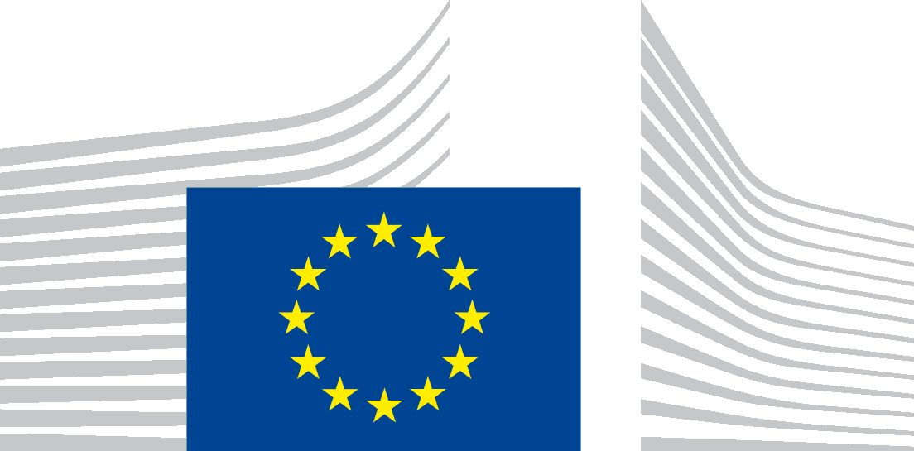

TECHNICAL SUPPORT INSTRUMENT (TSI) PROGRAMME
Regulation (EU) 2021/240 (TSI Regulation)

REQUEST FOR TECHNICAL SUPPORT
(Article 9 of the TSI Regulation)

DEADLINE: 31 October 2021

Member State:
Title of the request: | Gender mainstreaming in public policy and budget processes  Possibility to add subtitle (optional)  [Insert text: maximum 15 words]
Order of priority of the request:
Total number of requests:
Date of submission: | dd/mm/yyyy

COORDINATING AUTHORITY
Name
Address
Contact person | [Mr/Ms x, y, z]
Email
Telephone number

RECIPIENT NATIONAL AUTHORITY
Name
Address
Contact person | [Mr/Ms x, y, z]
Position
Email
Telephone number

Personal data provided in the request for technical support are processed in accordance with the applicable data protection rules. The privacy statement explaining the processing of personal data can be found in section 7 of the record at the following link: https://ec.europa.eu/dpo-register/detail/DPR-EC-04667

MULTI-COUNTRY REQUEST
0.1 | Is this a multi-country request? (a multi-country request is a request developed and/or submitted in collaboration with one or more authorities of another Member State)
☐ Yes
☐ No
0.2 | Please indicate the modality of this multi-country request
☐ This request is submitted on behalf of one or several other Member States
☐ One or several other Member States is/are submitting a similar/same request in parallel to this request
0.3 | Please indicate the name of the other Member State(s) concerned by this multi-country request
[Multiple choice list]

1 | DESCRIPTION OF THE PROBLEM/NEED TO BE ADDRESSED
1.1 | What is the problem/need to be addressed with the support requested?
This request is targeted at improving understanding of ways, how to take into the account impacts of policies on gender equality and gender budgeting, or to address the related policy gaps. Tailored technical support will enable Member States (MS) authorities to gain access to the EU and worldwide best practices on mainstreaming gender into public policy and to identify related reform opportunities in their respective administrations.
Gender equality is a fundamental human right but it is also a keystone of a prosperous modern economy that provides sustainable and inclusive growth. Gender equality is essential for ensuring that men and women can contribute fully at home, at work and in public life for the good of the society and economy at large.
The issue of gender equality is nevertheless not sufficiently reflected in national, regional and local policies. There has been no, or very little, progress in reaching gender equality and given COVID-19 pandemic, there has been a clear regression in certain domains. The gender gap persists in many areas, due to the lack of knowledge of methodologies used for mainstreaming gender equality into the public policies, for example fiscal policy. The awareness of gender equality perspective in public administration is very limited, restraining the necessary progress.
There is a clear need to better understand the portfolio/variety, latest methodologies and developments in gender equality policymaking, supporting diagnostic work for development of an action plan for further gender mainstreaming in public policy. The trends and importance of gender equality gaps can be misinterpreted in absence of reliable data and horizontally cross-cutting gender equality analyses. In many Member States, processes and comparative data are not available, and there is little experience and understanding of the benefits when considering the specificities of each sex in legislative impact assessments and performance budgeting.
The 2021 Report on Gender Equality in the EU shows the negative impacts of the COVID-19 pandemic on women. These findings are further reflected in the EIGE assessment that gender equality had regressed even before the pandemic. During the COVID-19 crisis, domestic violence increased, sectors traditionally employing more women were disproportionately affected, while women faced increasing care pressures at home. Moreover, women are facing increasing difficulties when looking for work. The need to improve gender equality has also been highlighted in several Member States’ Country Specific Recommendations.
Please provide justification of your specific problems/needs based on the above. You can also describe additional problems/needs relevant to your specific context.

[Insert Text; between 250-400 words]
1.2 | How broad is the problem/need? Does it affect a significant part/sector of the economy or extend across several policy areas (‘spill-over’)?
[Insert Text; between 250-300 words]
1.3 | How deep or severe is the problem/need? What would be the consequences of the problem? Were there any previous reform efforts? What was the impact of those efforts? What did not work and why?
[Insert Text; between 250-300 words]
1.4 | How urgent is the need to address the problem? Is there a specific deadline (at national, European or international level)?
[Insert Text; between 150-200 words]
1.5 | Provide relevant socio-economic (and environmental) indicators, data or evidence linked to the problem/need to be addressed. Please make sure that the data provided is related to the problem to be addressed and the support requested.
[Insert Text; between 150-200 words]
1.6 |  | Have other means / funding (at national, regional, EU, international level) been considered for addressing the problem identified? Which ones? If so, what is the complementarity of other funds with the technical support requested?
[Insert Text; between 100-200 words]

2 | INDICATIVE DESCRIPTION OF THE SUPPORT MEASURES REQUESTED AND THE ESTIMATED COST
2.1 | Briefly indicate the support measures envisaged (key outputs/deliverables) (e.g. diagnostic report, comparative analysis, recommendations, feasibility study, technical specifications for an IT tool, guidelines, etc.). Describe how these measures will help to address the problem identified.
This request helps identify measures needed to enhance measures related to gender equality. The beneficiary authority can choose only the general Module 1 or both Module 1 and the country-specific Module 2. Please note, the requesting Member State can also add additional measures.
Please tick relevant boxes and provide justification for each selected support measure.

☐ Module 1. Gender Mainstreaming and Gender Budgeting; methodologies, tools and best practices on international and EU levels: Multidimensional analysis of Gender Differences: What does Gender Mainstreaming mean and what possibilities does it bring? Methodological and practical implications of mainstreaming gender in the policy cycle, macroeconomic policies to mainstream gender, principles and methods for gender budgeting, as well as examples from different levels of government (EU, national, regional, local). Sharing practices on the structure and techniques for a gender sensitive analysis of public expenditures, positioning gender as a category of analysis. New obligations and soft law on gender budgeting and gender impact assessment at the EU and member state level will be reviewed (e.g. NGEU and MFF 2021-2027).
[Insert Text; between 100-200 words]

☐ Module 2: Building on to Module 1, a tailored deeper analysis per Member State including a general analysis of the mechanisms, tools and structures in place to monitor gender equality in the MS, facilitated by international experts.
[Insert Text; between 100-200 words]

☐ Other
[Insert Text; between 150-350 words]

2.2 | Indicate the possible duration of the support measures requested (all measures together) and, if available, an indicative timeline of each individual measure.
[Insert Text]
2.3 | Indicate the estimated total cost of the support measures requested (in EUR).
[Insert number; numerical field only, no spaces, commas, any other characters]
2.3.1 | Additional information (if known, please provide further explanation and indicative cost estimation for each key output/deliverable, including the foreseen activities).
[Insert Text between 50-100 words]
2.4 | Indicate the expected results (what is the ultimate objective that the technical support should achieve) and the expected use of these results (how will these be taken forward by the Member State).
[Insert Text; between 200-250 words]
2.5 | In case your entity has already received technical support under the SRSP or the TSI in the past, in an area relevant to the reform/support requested, please indicate how your entity has used the results of this support.
[Insert Text; between 200-250 words]
2.6 | Provide information on the administrative capacity of the recipient national authority (i.e. staff availability in relation with the requested support measures and the follow-up on their results). Please describe the team that will be responsible for coordinating/following the reform and the work of DG REFORM and its providers. If possible provide a description of the steering committee that could be put in place to supervise the reform.
[Insert Text; between 150-200 words]
2.7 | Indicate the names of stakeholders (e.g. other Ministries or beneficiaries) which may need to be involved in the design or implementation of the requested support measures.
[Insert Text; between 50-100 words]
2.8 | (If applicable,) indicate any envisaged provider of support (please do not provide names of private providers). Include explanations as to their know-how/capacity.
[Insert Text; between 50-100 words]

3 | CIRCUMSTANCES OF THE REQUEST
The requested support is linked to:
☐ | Preparation of Recovery and resilience plans under the Recovery and Resilience Facility
☐ | Implementation (incl. amendment and revision) of Recovery and Resilience plans under the Recovery and Resilience Facility
☐ | Reforms in the context of economic governance process (e.g. CSR, Country reports, etc.)
☐ | Implementation of Economic adjustment programmes
☐ | Implementation of Union priorities (e.g. CMU, Energy Union, Customs Union, etc.)
☐ | Implementation of Union law (e.g. infringements)
☐ | Implementation of Member States’ own reform priorities to support recovery, sustainable economic growth, job creation and enhance resilience
3.1. | Additional information
Enhancing Gender Equality addresses the key European priority of equality, social cohesion and an economy that works for all. It is also essential for a dynamic economy that works for all. The Gender Equality Strategy 2020–2025 aims towards a Union where women and men, girls and boys, in all their diversity, are free to pursue their chosen path in life, have equal opportunities to thrive, and can equally participate in and lead our European society.

[Add relevant explanations as appropriate:
i.e. number of the CSR; policy priority; relevant national strategy documents, etc.; additional information on the Recovery and Resilience Plans under the Recovery and Resilience Facility]
[Insert Text; indicatively between 150-200 words]

DISCLAIMERS:
Please note that the request for support is fully subject to the principles governing the TSI Regulation and Regulation No 2018/1046 on the Financial Regulation applicable to the General Budget of the Union. In compliance with the principle of prohibition of double funding, the recipient national authority shall immediately inform the European Commission of other related on-going actions financed by the EU budget. In no circumstances, shall the European Commission finance the same costs twice.
By submitting this request, the Member State accepts that, should the request for support be selected for funding under the TSI, the Member State will confirm to the Commission that there is no overlap between the request selected under the TSI and concrete actions funded under other EU instruments and that double funding is not present for this selected request.
Please note that the Commission shall establish a single online public repository through which it may, subject to applicable rules and on the basis of consultation with the Member States concerned, make available final studies or reports produced as part of eligible actions set out in the TSI Regulation. Where justified, the Member States concerned may request that the Commission not disclose such documents without their prior agreement.
Please note that the Commission promotes "zero tolerance to fraud and corruption". In this context, the Commission implements controls to prevent, detect and address irregularities/fraud instances, whether these occur in connection with its activities and funds, and inside or outside its organisation. In order to counter fraud affecting the financial interests of the Union (art. 325 TFEU), it is of paramount importance that our partners in the Member States and the providers of support strive to achieve an equivalent stand against fraud.
For the requests linked with the RRPs: The provision of the technical support under the TSI is without prejudice to the responsibility of Member States in relation to the fulfilment of relevant milestones and targets of the RRP and is without prejudice to the assessment that the Commission carries out in relation to the Member State’s relevant request for payment.

Regulation (EU) 2021/240 of the European Parliament and of the Council of 10 February 2021 establishing a Technical Support Instrument, OJ L 57, 18.2.2021, p. 1–16.
The term ‘gender’ is defined in Article 3 of the Council of Europe’s Istanbul Convention as ‘the socially constructed roles, behaviours, activities and attributes that a given society considers appropriate for women and men’. The term ‘gender equality’ focuses on the elimination of all inequalities and the promotion of equality between men and women, boys and girls, going beyond the mere biological differences between women and men, also referring to social roles.
Gender equality strategy | European Commission (europa.eu)
Let's turn up the power for more gender equality (europa.eu)
https://eur-lex.europa.eu/legal-content/FI/TXT/PDF/?uri=CELEX:52020DC0152&from=EN

