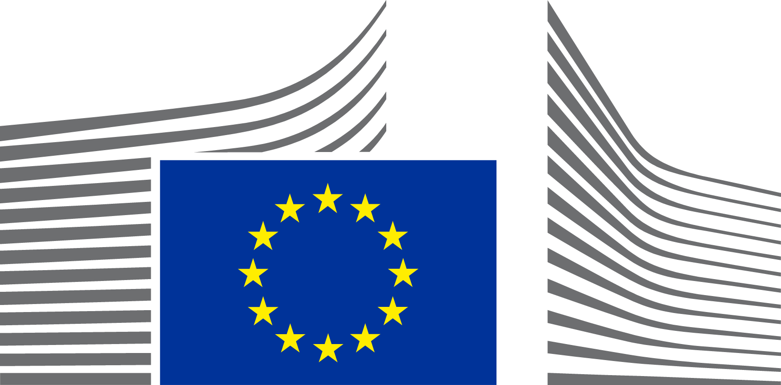 | EUROPEAN COMMISSION  DIRECTORATE-GENERAL FOR JUSTICE AND CONSUMERS  Directorate C – Rule of Law, Fundamental Rights and Democracy  Unit C.4 – Democracy, Union Citizenship and Anti-Corruption

MINUTES
Joint meeting of the Network of National Contact Points for the application of the Political Advertising Regulation and of the Working Group on political campaigning of the European Cooperation Network on Elections
23 January 2026
Online

The joint meeting of the Political Advertising Regulation Network of National Contact Points and of the ECNE working group on political campaigning took place on 23 January, lasting for one hour. The meeting was held in a positive atmosphere, with 61 participants from the two networks, who acknowledged the added value of this first exchange of views.
Welcome and presentation of the networks
The Commission presented the two networks and explained the importance of close cooperation between the Network of National Contact Points and ECNE, as mandated by the Political Advertising Regulation (Article 22(9)). This set the stage for a discussion on practical ways to foster cooperation between the two networks.
Cooperation methods
The discussion focused on possible methods of cooperation, such as regular joint meetings, targeted sessions on specific topics, participating in common surveys, working together on projects, and supporting the organisation of table-top exercises on elections. Several participants, including IE, FR, and NL, expressed their interest in such cooperation. IE electoral commission requested a mapping of authorities that are members of the ECNE political campaigning working group and of National Contact Points for the Political Advertising Regulation. The FR National Contact Point proposed working with fewer interested authorities in working groups to facilitate more focused discussions. AT and MT stressed the importance of ensuring that cooperation remains efficient, while NL raised practical questions about working methods.

Areas of Common Interest
The Commission presented possible areas of common interest, including discussing concepts of the Political Advertising Regulation related to the political campaigning ecosystem and sharing information on various topics. These topics included lists of national, regional, and local authorities providing messages related to elections or referendums, examples of communication campaigns, national rules on the presentation of candidates, categories of entities that would fall under the definition of political actors, national rules on the recognition/accreditation of election observers, and lists of competent authorities responsible for the auditing or supervision of political actors.
AOB and conclusions
The PT ECNE member asked for more information on the implementation of the Political Advertising Regulation, its current state of play, and any challenges or difficulties encountered.

